**INDEX**

|  |  |  |
| --- | --- | --- |
| **Sr.no** | **Title** | **Page.no** |
| **Part-I Introduction** | | |
| **1** | **Introduction to Project** |  |
|  | * **Project Profile** |  |
| **Part-II System Analysis and Design** | | |
| **2** | **Project Planning** |  |
|  | * **Scope of the Project** |  |
|  | * **Project Team** |  |
| **3** | **System Design** |  |
|  | * **Data Flow Diagrams** |  |
|  | * **Database Design** |  |
| **Part-III Implementation Details** | | |
| **4** | **Screen Layouts** |  |
| **Part-IV Appendix** | | |
| **5** | **Bibliography** |  |

**PART-I**

**INTRODUCTION**

**1. INTRODUCTION TO PROJECT**

**Project Title:** Academic activity tracking system

**Project Profile**

Academic activity tracking system helps teachers to mark online attendance of students during class & reduce manual work. It is used to track student's attendance, absent record, assignment, question bank, exam, attendance history & other related documents.

**Purpose**

* Academic activity tracking system records and maintains student's attendance data using smart devices.
* The system collects attendance records in the system and manages, stores and processes the data.
* It generates daily attendance reports that help the faculty to track student's presence with high accuracy and efficiency.
* If also generate assignment, question bank and exam

**Project Modules**

**Admin Module**:

* Admin can manage course.
* Admin can manage semester.
* Admin can manage subject.
* Admin can manage teacher.
* Admin can manage Allotment subject semester wise.
* Admin can show different types of data.

**Teacher Module:**

* Teacher can manage Attendance like insert, update.
* Teacher can manage lecture information.
* Teacher can generate Assignment.
* Teacher can generate question bank.

**Student’s Module:**

* Student’s can view attendance reports.
* Student’s can submit assignment.
* Student’s can give the exam online.

**Tools & Technology:** PHP & MY-SQL, Boot Strap Frame work

**Team Size:** 1 member

**Internal Project Guide:**

**Submitted To:** KBS Commerce & NATRAJ Professional Science Collage

**Duration:** 3 Months

**Project Developed By:** Hetvi Gohil

**PART-II**

**SYSTEM ANALYSIS**

**&**

**DESIGN**

**2. Project Planning**

**Scope of the Project**

* Implementing secure login and role-based access for admin, teachers, Students.
* When admin login is capable for handling all the web page information i.e., Course Entry Page, Semester Entry Page, Subject Entry Page, Lecturer Entry Page, Subject allotment Entry Page, Generate Roll number.
* When lecturer login is capable for making entry of attendance of Students, manage the lectures information and manage the assignment and exam questions.

**Project Team**

There is only one member in this project whose details are as follows:

|  |  |
| --- | --- |
| **Personal Profile** | |
| **Name** |  |
| **Address** |  |
| **Contact No.** |  |
| **E-mail Address** |  |
| **Seat No.** |  |

**3. System Design**

**Data Flow Diagram:**

**Level-1**

Id & Password

Id & Password

**Attendance Management System**

**Level-0**

Lecturer

Admin

**Context Level**

**Admin**

Transaction Process

Retrives Id & Password

Id & Password

**4**

**Report**

**Process**

**3**

**Transaction**

**Process**

**Lecturer**

All Data from Database

Transaction Process

Master Information

Master Information

**2**

**Master**

**Process**

Retrives Id & Password

Id & Password

**1**

**Login**

**Process**

**Database**

**Process-1**

**Level-2Process-2**

User Data

User Data

Retrives Id & Password

Retrives Id & Password

Id & Password

Id & Password

TM_USER

**Lecturer**

**Admin**

**1.1**

**Login Check Process**

**Level-2**

Student Details

Student Details

Lecturer Details

Lecturer Details

Semester Details

Semester Details

Course Details

Course Details

TM_STUDENT

TM_LECTURER

TM_SEM

TM_COURSE

**Admin**

**2.4**

**Student Entry**

**2.3**

**Lecturer Entry**

**2.2**

**Semester Entry**

**2.1**

**Course Entry**

**Process-3**

**Level-2**

Suballotement Details

**Admin**

**Lecturer**

TM_LEC_INFO

**3.2**

**Lecture Attendance Information**

Lecture Attendance Details

**3.1**

**Suballotement Information**

TM_SUBALLOTEMENT

**Process-4**

**Level-2**

Data From Database

Report

Report

**4.2**

**Subject Report**

**4.1**

**Lecturer Report**

**Database**

**DataBase-Design**

Table Name: **TM_USER**

Primary Key: USER_ID

Description: This table is used for storing Login details

|  |  |  |  |
| --- | --- | --- | --- |
| **Field Name** | **Type & Size** | **Constraints** | **Description** |
| USER_ID | INT | Primary Key |  |
| USER_NAME | VARCHAR(50) | Not Null |  |
| PASSWORD | VARCHAR(50) | Not Null |  |

Table Name: **TM_COURSE**

Primary Key: COURSE_ID

Description: This table is used for storing Course details

|  |  |  |  |
| --- | --- | --- | --- |
| **Field Name** | **Type & Size** | **Constraints** | **Description** |
| COURSE_ID | INT | Primary Key |  |
| COURSE_NAME | VARCHAR(50) | Not Null |  |

Table Name: **TM_SEM**

Primary Key: SEM_ID

Description: This table is used for storing Semester details

|  |  |  |  |
| --- | --- | --- | --- |
| **Field Name** | **Type & Size** | **Constraints** | **Description** |
| SEM_ID | INT | Primary Key |  |
| SEM_NAME | VARCHAR(50) | Not Null |  |

Table Name: **TD_COURSE**

Primary Key: DC_ID

Description: This table is used for storing Subject details

|  |  |  |  |
| --- | --- | --- | --- |
| **Field Name** | **Type & Size** | **Constraints** | **Description** |
| DC_ID | INT | Primary Key |  |
| COURSE_ID | INT | Foreign Key |  |
| SEM_ID | INT | Foreign Key |  |
| SUB_CODE | VARCHAR(50) | Not Null |  |
| SUB_NAME | VARCHAR(50) | Not Null |  |

Table Name: **TM_LECTURER**

Primary Key: LEC_ID

Description: This table is used for storing Lecturer details

|  |  |  |  |
| --- | --- | --- | --- |
| **Field Name** | **Type & Size** | **Constraints** | **Description** |
| LEC_ID | INT | Primary Key |  |
| FIRST_NAME | VARCHAR(50) | Not Null |  |
| MIDDLE_NAME | VARCHAR(50) | Not Null |  |
| LAST_NAME | VARCHAR(50) | Not Null |  |
| GENDER | BIT | Not Null |  |
| DOB | DATETIME | Not Null |  |
| QULIFICATION | VARCHAR(50) | Not Null |  |
| SPECIFICATION | VARCHAR(50) | Not Null |  |
| DESIGNATION | VARCHAR(50) | Not Null |  |
| DOJ | DATETIME | Not Null |  |
| CONTACT | VARCHAR(50) | Not Null |  |
| EMAIL | VARCHAR(50) | Not Null |  |

Table Name: **TM_STUDENT**

Primary Key: S_ID

Description: This table is used for storing Student details

|  |  |  |  |
| --- | --- | --- | --- |
| **Field Name** | **Type & Size** | **Constraints** | **Description** |
| S_ID | INT | Primary Key |  |
| COURSE_ID | INT | Foreign Key |  |
| SEM_ID | INT | Foreign Key |  |
| FIRST_NAME | VARCHAR(50) | Not Null |  |
| MIDDLE_NAME | VARCHAR(50) | Not Null |  |
| LAST_NAME | VARCHAR(50) | Not Null |  |
| DOB | DATATIME | Not Null |  |
| GENDER | BIT | Not Null |  |
| ADDRESS | VARCHAR(50) | Not Null |  |
| GR_NO | VARCHAR(50) | Not Null |  |
| ENROLLMENT_NO | VARCHAR(50) | Not Null |  |
| CONTACT_NO | VARCHAR(50) | Not Null |  |
| PARENT_C_NO | VARCHAR(50) | Not Null |  |
| EMAIL_ID | VARCHAR(50) | Not Null |  |
| DOA | DATETIME | Not Null |  |

Table Name: **TM_SUBALLOTEMENT**

Primary Key: SA_ID

Description: This table is used for storing Suballotement details

|  |  |  |  |
| --- | --- | --- | --- |
| **Field Name** | **Type & Size** | **Constraints** | **Description** |
| SA_ID | INT | Primary Key |  |
| COURSE_ID | INT | Foreign Key |  |
| SEM_ID | INT | Foreign Key |  |
| SUB_CODE | VARCHAR(50) | Foreign Key |  |
| LEC_ID | INT | Foreign Key |  |
| INDATE | DATETIME | Not Null |  |

Table Name: **TM_LECT_INFO**

Primary Key: LECT_ID

Description: This table is used for storing Lecture details

|  |  |  |  |
| --- | --- | --- | --- |
| **Field Name** | **Type & Size** | **Constraints** | **Description** |
| LECT_ID | INT | Primary Key |  |
| LECT_DATE | DATETIME | Not Null |  |
| COURSE_ID | INT | Foreign Key |  |
| SEM_ID | INT | Foreign Key |  |
| LECT_NO | INT | Not Null |  |
| PO_STATUS | VARCHAR(50) | Not Null |  |
| SUB_CODE | VARCHAR(50) | Not Null |  |
| LECT_TOPIC | VARCHAR(50) | Not Null |  |
| LECT_METHOD | VARCHAR(50) | Not Null |  |
| AB_NO | VARCHAR(50) | Not Null |  |
| LEC_ID | INT | Foreign Key |  |

**PART-III**

**Implementation**

**Details**

**6. Screen Layouts**

**1. Login Form:-**

Used to Login to system.

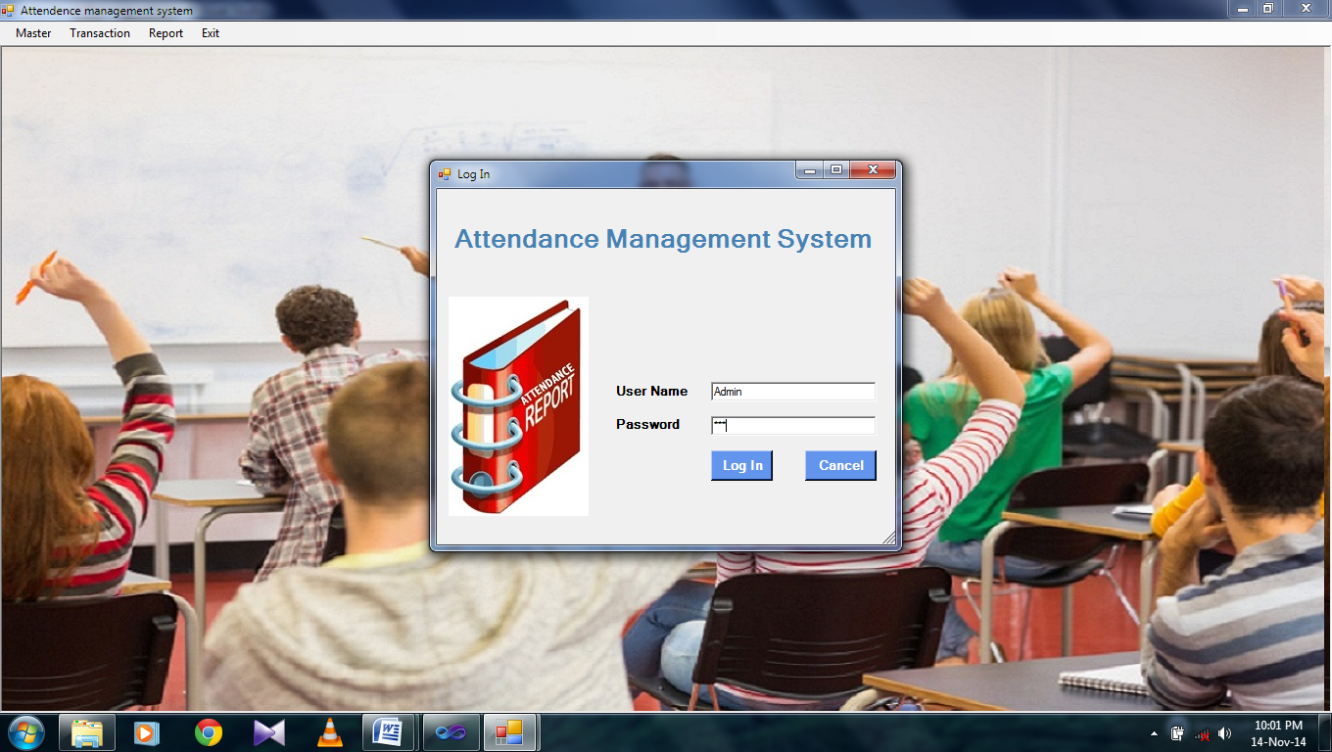

**2.Master Form: -**

Main MDI form that contain menu to access all the form.



**3. Course Entry**

Used Make Entry from Course Details.

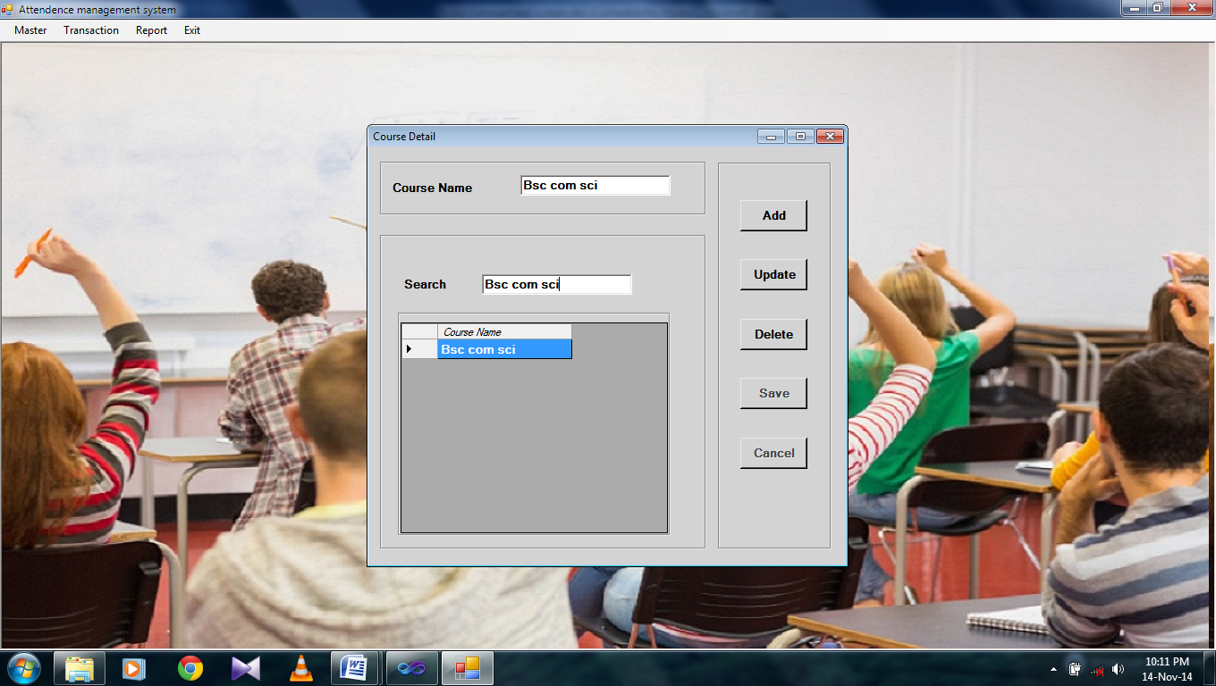

**Semester Entry:-**

Used Make Entry from Semester Details.

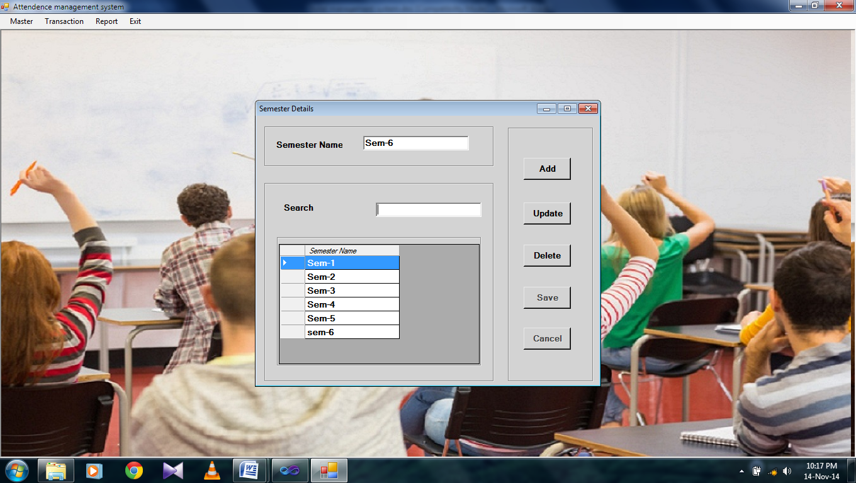

**Subject Entry:-**

Used Make Entry from Subject Details.

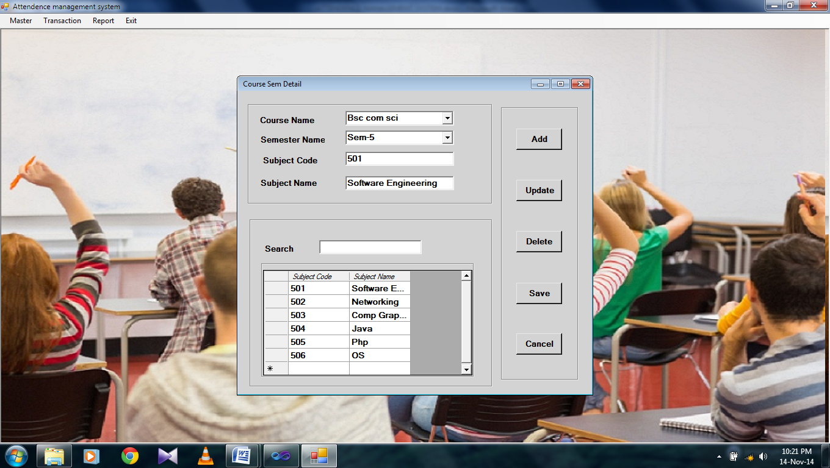

**Lecturer Entry:-**

Used Make Entry from Lecturer Details.

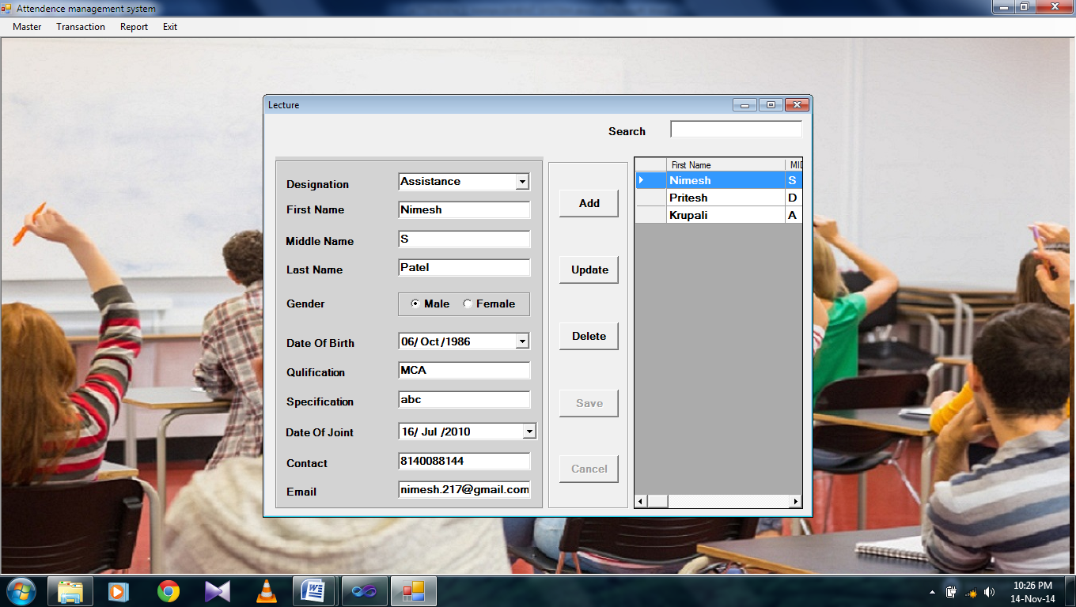

**Student Entry:-**

Used Make Entry from Student Details.

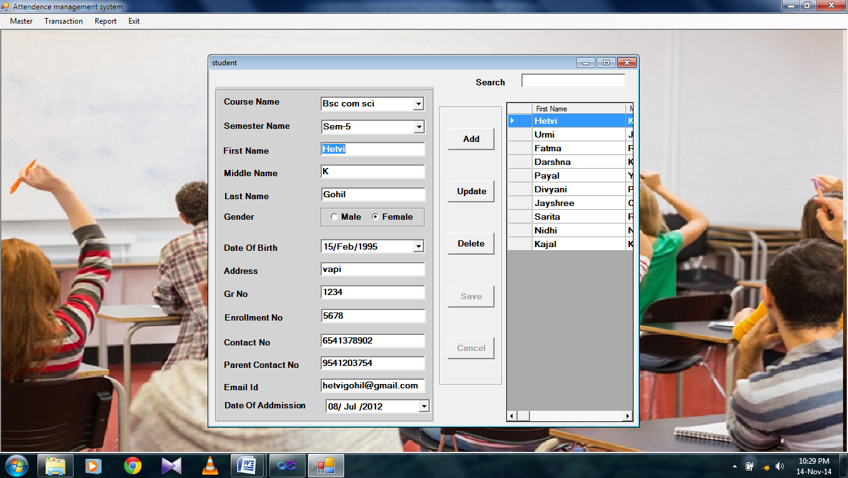

**Suballotement Entry:-**

Used Make Entry from Suballotement Details.

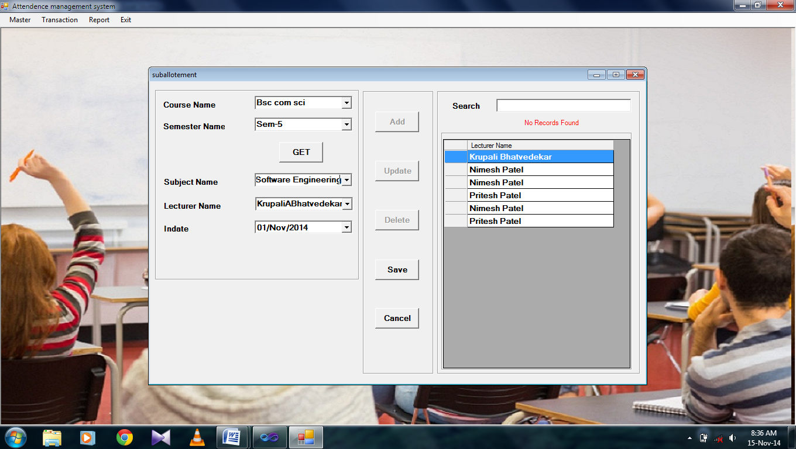

1. **Lecture Information Entry:-**

Used Make Entry from Lecture Information Details.

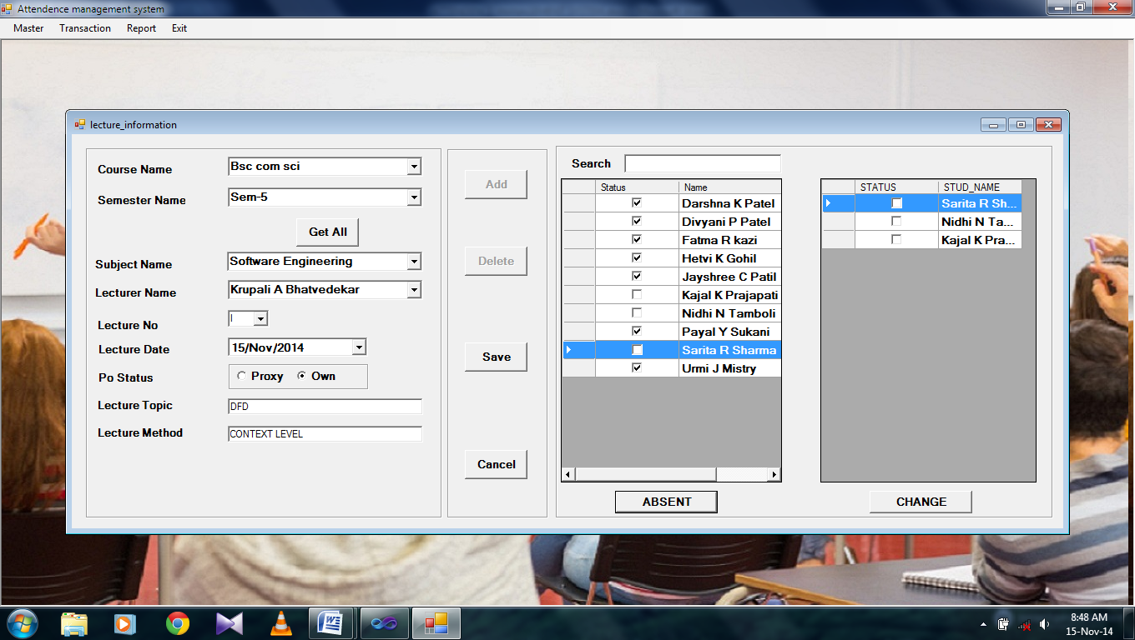

**10. Lecture Report:-**

Used Make Entry from Lecture Report.

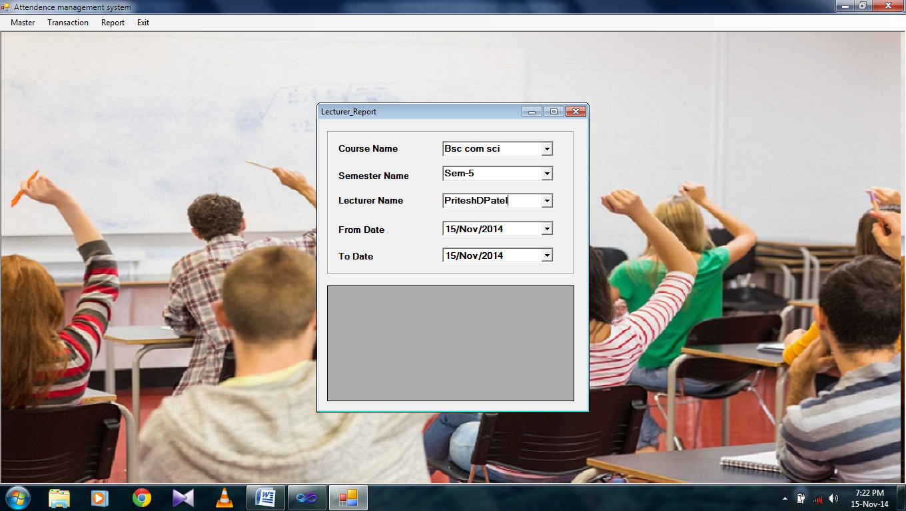

**11. Subject Report:-**

Used Make Entry from Subject Report.

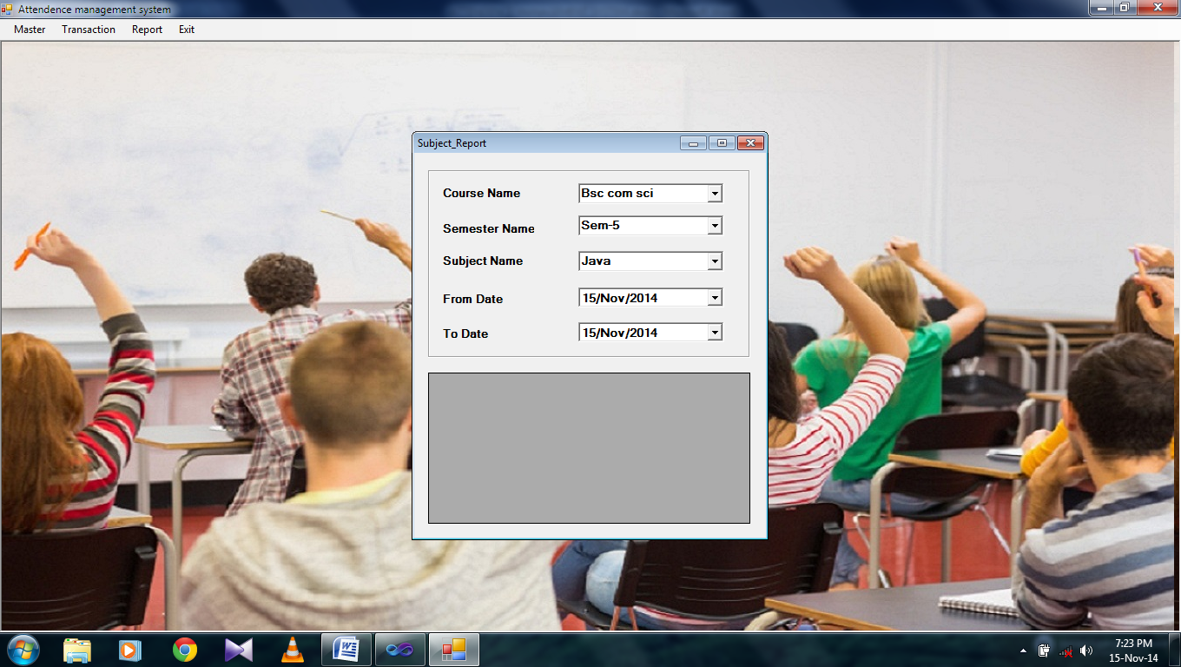

**PART-IV**

**Appendix**

**5.Bibliography**

**Books:**

**Search Engine:**

**Online Resource :**